|  |
| --- |
| lewis-and-clark-and-me-a-dogs-tale.jpg because-of-winn-dixie.jpg Poppy-9780380727698.jpg    **Animals Are Characters, Too: Characters Who Gallop, Bark, and Squeak**  ***How do we portray animals in writing?*** |
|  |

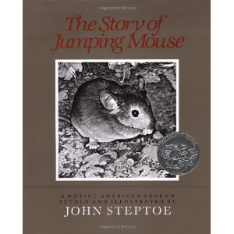 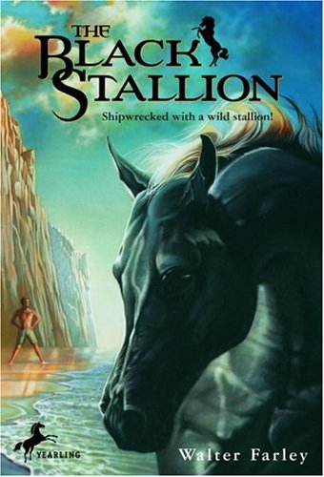 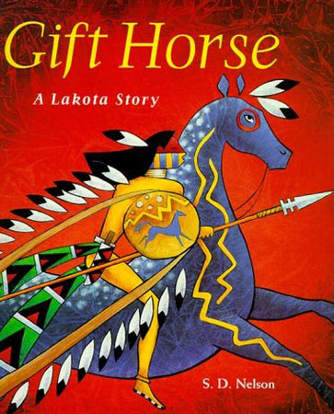

Name:_______________________________

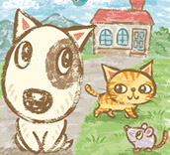

Day 1

Score your learning goal for today.

Before:

After:

Do you have a pet? What is your pet’s name?

List 3 characteristics about your pet:

If you do not have a pet, would you like one? Why?

* _____________________________________________
* _____________________________________________
* _____________________________________________
* _____________________________________________
* _____________________________________________

Video #1

Characteristics of the animals Evidence from the video

Video #2

Characteristics of the animals Evidence from the video

Day 2